Deep Learning:
It is a subfield of machine learning that utilizes Artificial neural network with multiple layers to analyze data and learn complex patterns.its inspired by the structure and function of hunman brain and particulary effective at handling large ,unstructured datasets like image,text,audio etc.

Neural Network(perceptron)
Neural network is method of artificial intelligence that teaches computers to process the data in a way that is inspired by human brain.it's composed of interconnected nodes, or "neurons," arranged in layers, that process and transmit data.

Single layer perceptron:
In slp Input layer directly connects to the output layer.here there is no hidden layer.

How it works?
First the perceptron recieves multiple input signals each with associated weight .inputs are multiplied by corresponding weights results are summed up and the output is either 0 or 1

MultiLayer Perceptron:
It is type of artificial neural network categorized by multiple layers of interconnected nodes ,organised in one input layer one or more hidden layer and one output layer.

Neuron:A neuron in a neural network is a mathematical function that takes in inputs, multiplies them with weights, adds a bias, and passes the result through an activation function to produce an output.

Inputs:inputs are the raw values that neuron will process.
Weights:each input associate with weight.which represents the strength blw input and neuron.
Bias: Bias is the constant value added the weighted sum it helps when even all the inputs are zero.
Activation:The weighted sum is introduced through an activation function.so that it introduces non linearity to the neurons.so that it learn complex patterns.

Forward Propogation:
Forward propagation is the fundamental process in a neural network where input data passes through multiple layers to generate an output. It is the process by which input data passes through each layer of neural network to generate output.

Dense Neural Network:
It is also known as fully connected or feed forward neural network each neuron in one layer is connected to every neuron in the adjacent layer.

In Neural network depth refers to number of sequential layers in the network and width refers to no of nodes in single layer.

Activation Functions (Sigmoid, ReLU, Tanh, Softmax)
Activation function introduce non linearity to the neural networks,enabling them to learn complex patterns. Common activation function we use is sigmoid,tanh,relu etc

Sigmoid:maps input values to the range(0,1),often used for binary classification problems.where output represents probability.
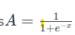

Tanh:maps input values to the range(-1,1),similar to sigmoid it handles both positive and negative data.
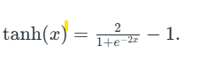
Relu:: Outputs the input if it's positive, otherwise outputs zero.

Softmax:Softmax normalizes the output of the neural network into a probability distribution, where each value is between 0 and 1, and the sum of all values equals 1. all the outputs sum is 1

Vanishing and exploding gradient problems :
These are the problems arrised during training deep neural networks.
Vanishing Gradient Problem:
The vanishing gradient problem occurs when the gradients, during backpropagation, become progressively smaller as they move from the output layer towards the input layer.

Exploding gradient problem:
Exploding gradient problem is the opposite of vanishing gradient problem.it occurs when the gradients become extremely large during backpropogation.

Loss Functions:
It measures the error between models prediction and actual target values.the model uses this feedback to update its weight.

MSE:
MSE calculates the average squared difference between predicted and actual values.
It is used in regression problems while predicting continuous numeric values.

Cross Entropy: it is mainly used for classification tasks. It measures the performance of classification model by quantifing the difference between predicted probability and true label.

Binary cross entropy: it is mainly used to measure the performance of binary classification problems
How it works?
It takes two classes as input and represent single output neuron with sigmoid activation function and two output neurons with softmax activation

Categorical Cross Entropy (CCE):
it is mainly used for to measure the performance of multi class classification model.
How it works?
It takes multiple classes as input and applies softmax activation function and one output neuron.

TASKS
Implement MSE and Binary Cross Entropy from scratch
import numpy as np

def mse(predictions, targets):
"""
Calculates the Mean Squared Error (MSE) loss.

Args:
predictions (numpy.ndarray): Predicted values.
targets (numpy.ndarray): Actual target values.

Returns:
float: The MSE loss.
"""
return np.mean((predictions - targets) ** 2)

def binary_cross_entropy(predictions, targets):
"""
Calculates the Binary Cross-Entropy (BCE) loss.

Args:
predictions (numpy.ndarray): Predicted probabilities (values between 0 and 1).
targets (numpy.ndarray): Actual binary target values (0 or 1).

Returns:
float: The BCE loss.
"""
# Clip predictions to avoid numerical instability (log(0) or log(1))
predictions = np.clip(predictions, 1e-15, 1 - 1e-15)
return -np.mean(targets * np.log(predictions) + (1 - targets) * np.log(1 - predictions))

# Example Usage
if __name__ == '__main__':
# Generate some dummy data
y_true = np.array([0, 1, 0, 1, 1])
y_pred_regression = np.array([0.1, 0.9, 0.2, 0.8, 0.7])
y_pred_classification = np.array([0.2, 0.8, 0.3, 0.7, 0.9])

# Calculate MSE
mse_loss = mse(y_pred_regression, y_true)
print(f"MSE Loss: {mse_loss}")

# Calculate BCE
bce_loss = binary_cross_entropy(y_pred_classification, y_true)
print(f"Binary Cross-Entropy Loss: {bce_loss}")

MSE Loss: 0.038
Binary Cross-Entropy Loss: 0.2529995012327421

Back Propogation
Backpropagation is the process of computing gradients of the loss function with respect to each weight in the neural network.it usually update the weights effeciently using gradient descent.

Chain rule of calculus for computing gradients
Chainrule helps us to compute the derivative of function that has multiple nested functions so that it becomes simpler,more managable parts,multiplying this individual derivatives to find the overall gradient.

Why backprop is efficient (reuse of partial derivatives)
In backpropagation it will compute the gradient and store it and reuse it
So that it avoids recaluculating the same derivative multiple times.

Gradient Descent
It is an optimization algorithm used to minimize the loss in neural network by updating the weights in the direction that reduces the error.

Vanilla Gradient Descent:

Vanilla Gradient Descent is the original, simplest form of gradient descent. It updates all weights once per full pass through the entire dataset.

Stochastic Gradient:

Stochastic Gradient Descent is a variant of vanilla gradient descent that updates weights one sample at a time, rather than using the entire dataset per update.

Mini-Batch Gradient Descent:

MBGD processes small batches of data at a time to compute the gradient and update weights.

Momentum
Gradient descent, in its basic form, can be slow and inefficient, especially when dealing with complex loss landscapes. It can get stuck in local minima or oscillate wildly in regions with high curvature, wasting computational resources.
Momentum introduces a "velocity" term, which is an exponentially weighted average of past gradients. This means the algorithm doesn't just consider the current gradient but also remembers the direction and magnitude of past movements.

RMSProp
It adjusts the learning rate for each parameter based on history of gradients.

ADAMS OPTIMIZER:
Adam (Adaptive Moment Estimation) optimizer combines the advantages of Momentum and RMSprop techniques to adjust learning rates during training. It works well with large datasets and complex models because it uses memory efficiently.

TASKS
Plot learning curves of different optimizers
import numpy as np
import matplotlib.pyplot as plt
import torch
import torch.nn as nn
import torch.nn.functional as F
from torch.optim import SGD, Adam, RMSprop

# XOR dataset
X = torch.tensor([[0., 0.], [0., 1.], [1., 0.], [1., 1.]])
y = torch.tensor([[0.], [1.], [1.], [0.]])

# Define MLP
class MLP(nn.Module):
def __init__(self):
super().__init__()
self.fc1 = nn.Linear(2, 4)
self.fc2 = nn.Linear(4, 1)

def forward(self, x):
x = F.relu(self.fc1(x))
return torch.sigmoid(self.fc2(x))

# Training function
def train_model(optimizer_class, name, epochs=2000, lr=0.01):
model = MLP()
optimizer = optimizer_class(model.parameters(), lr=lr)
criterion = nn.BCELoss()
losses = []
for epoch in range(epochs):
optimizer.zero_grad()
y_pred = model(X)
loss = criterion(y_pred, y)
loss.backward()
optimizer.step()
losses.append(loss.item())
return losses

# Run training for all optimizers
optimizers = {
"SGD": SGD,
"SGD + Momentum": lambda params, lr: SGD(params, lr=lr, momentum=0.9),
"RMSProp": RMSprop,
"Adam": Adam
}

loss_curves = {name: train_model(opt, name) for name, opt in optimizers.items()}

# Plot curves
plt.figure(figsize=(10, 6))
for name, losses in loss_curves.items():
plt.plot(losses, label=name)
plt.title("Learning Curves of Different Optimizers on XOR Task")
plt.xlabel("Epoch")
plt.ylabel("Binary Cross-Entropy Loss")
plt.legend()
plt.grid(True)
plt.tight_layout()
plt.show()

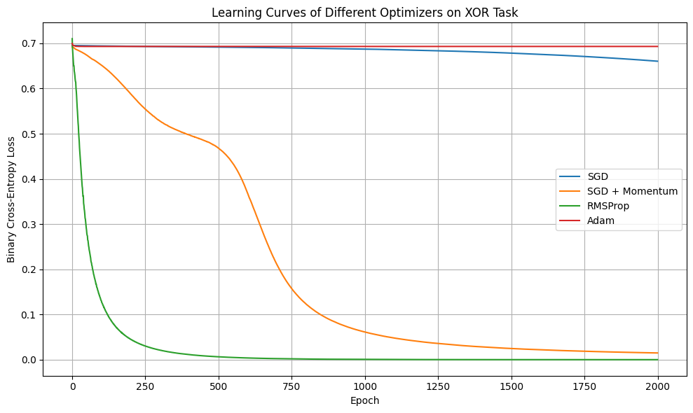

Weight Intialization
Weight intialization is the process of assigning intial values to the weights in neural networks before training begins.

Why poor initialization breaks training :
Weights plays key role in training if it is intialized poorly then it may leads to vanishing gradient problem,Exploding gradient problem,symmetric breaking failure(it will start with same weights then it unable to learn complex patterns).

Xavier Intialization:
Xavier initialization is a weight initialization technique that initializes the weights of a neural network with random values drawn from a distribution with a specific variance.

Regularization (Dropout, L2) :
Regulariztion is used to prevent overfitting by penalizing model complexity.

L2 Regularization: It is also called ridge regularization,is a technique used in machine learning to reduce overfitting by penalizing large weights toa model.so adds penality to large weights for the model to keep them small.

DropOut: This too helps in prevent overfitting by randomly droppping/deactivating a portion of neurons during training.during each training iteration some neurons are temporarily ignored. So that it improves generalization and reduces the risk of overfitting.

Overfitting:
Overfitting in deep learning occurs when a neural network learns the training data too well, including noise and outliers, leading to poor generalization on new, unseen data.

L1 vs L2 regularization on weights :
Both L1 and L2 penalizes the weights . In L1 pushes weights towards zero.making some of them exactly zero.In L2 shrinks weights towards zero but doesnot make them exactly zero.

